Georgia Society of CPAs
Annual Report on Oversight
Issued February 13, 2026

I. Administering Entity Oversight Process and Procedures
Oversight of Peer Reviews and Reviewers
The Georgia Society of CPAs Peer Review Committee selects various peer reviews for oversight. The selections are made randomly or are based on (but not limited to) suggestions from the (RAB) Report Acceptance Body Committee and are usually based the committee’s concerns about a reviewer or a firm.

Firms
The selection of firms to be reviewed is based on several factors including (but not limited to)
1. Previous non-pass reports
2. If this is the firm’s initial system review
3.If the firm conducts engagements in high-risk industries.

Reviewers
All peer reviewers are subject to oversight, and they may be selected based on several factors including (but not limited to)
- Random selection
- Frequent submission of pass reports with no MFCs or FFCs
- Conducting a significant number of reviews for firms with audits in high-risk industries
- Performance of their first peer review
- Performing high volumes of reviews
- A high volume of reviewer feedback
- Performance deficiencies or a history of performance deficiencies.

Oversight Process
An active member in the Georgia Society of CPAs Peer Review program or a contracted technical reviewer performs oversight of engagements. For a system review and must-select engagement oversights, members must have team captain experience and high risk industry experience, if applicable. Selection of the oversight reviewer is on a volunteer basis. If there are no volunteers, The Georgia Society of CPAs Peer Review Executive Committee will appoint a member to complete the oversight.
All oversight reviewers are paid by The Georgia Society of CPAs at the maximum technical reviewer administrative rate. For on-site reviews, the rate is applied from door-to-door. The current IRS mileage rate and other incidental expenses are reimbursed in addition to the hourly rate.
The AICPA Peer Review Program Oversight checklists are available on the AICPA peer review website. Oversight reports are uploaded into the AICPA’s PRIMA (Peer Review Integrated Management Application) system. The final report is prepared on the reviewer’s letterhead and submitted to The Georgia Society of CPAs Peer Review Executive Committee. The reviewer may respond and make corrections as deemed necessary.

Minimum Requirements
In 2025, The Georgia Society of CPAs was required to conduct minimal oversight on 2% of all reviews performed in a twelve-month period of time and within the 2% selected, there must be at least two of each type of peer review evaluated (system and engagement reviews). * See section III for details on oversights performed

Administrative Oversight
GSCPA participates in the annual AICPA Plan of Administration review and benchmark reporting three times per year which allows the AICPA and GSCPA’s peer review executive committee to monitor administrative procedures. Additionally, the GSCPA peer review executive committee receives updates on peer review statistics that include (but are not limited to) open reviews, late reviews, results of reviews presented to RAB, oversights in process, & open corrective actions and implementation plans. These updates are given after each benchmark reporting period
* See section III for details on the most recent administrative oversight performed

II. Summary of Peer Review Program(s)
The Georgia Society of CPAs administers the AICPA Peer Review Program.

The Georgia State Board of Accountancy (SBOA) requires all firms in Georgia, who provide attestation or compilation services as part of their public accounting process, to be enrolled in a practice monitoring program. The SBOA has designated The Georgia Society of CPAs as an authorized report acceptance body to approve peer review reports issued for firms enrolled in peer review programs administered by The Georgia Society of CPAs.

 | AICPA Peer Review Program
Sole Practitioners | 135
2 to 5 | 227
6 to 10 | 88
11 to 19 | 42
20 to 49 | 16
50 to 99 | 3
100 + | 0
Total enrolled firms | 511

Results of Peer Reviews Accepted During the Year 2025

a) Results by Type of Peer Review and Report Issued

 | AICPA Peer Review Program
System Reviews |  | %
Pass | 68 | 66
Pass with deficiency(ies) | 9 | 9
Fail | 25 | 25
Total | 102 | 100
Engagement Reviews |  | %
Pass | 55 | 83.33
Pass with deficiency(ies) | 10 | 15.15
Fail | 1 | 1.52
Total | 66 | 100

b) Type and Number of Reasons for Report Deficiencies for System Reviews

 | AICPA Peer Review Program
Leadership responsibilities for quality within the firm (“the tone at the top”) | 2
Relevant ethical requirements | 0
Acceptance and continuance of client relationships and specific engagements | 0
Human resources | 2
Engagement performance | 6
Monitoring | 2
Total | 12

c) Number of Engagements Not Performed or Reported on in Conformity with Professional Standards in All Material Respects (Nonconforming engagements)

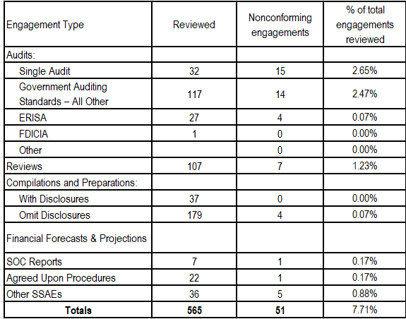

d) Summary of Required Follow-up Actions (includes corrective actions and implementation plans)

Type of Follow-Up Action | AICPA Peer Review Program
Agree to Pre-issuance Review by TC/Outside Party | 4
Other | 1
Request to Have Accelerated Review | 0
Submit Monitoring Report to Team Captain/Outside Party for Review | 1
Submit Proof of Certain CPE Taken | 19
Submit to TC/Outside Party Post-issuance Review of Subsequent Engagements w/o wp's | 0
Submit to TC/Outside Party Post-issuance Review of Subsequent Engagements w/ wp's | 0
TC/Outside Party Review Correction of Non-Conforming Engagements | 0
TC/Outside Party to Review Firm's Remedial Actions in LOR | 0
Total | 25

III. Oversight Process and Oversight Results

a) Peer reviews

AICPA Peer Review Program Firms

Type of Peer Review | Must Select Engagement  (GAGAS, ERISA, FDICIA, SOC) | Total Oversights
System | 1 | 2
Engagement | 0 | 2

b) Oversight Performed on the AE

Date of Last Administrative Oversight Performed by AICPA Oversight Task Force | September 18-20, 2024

The results of our most recent oversight performed by the AICPA Oversight Task Force, which covers only the AICPA Peer Review Program, are available on the AICPA’s website.

